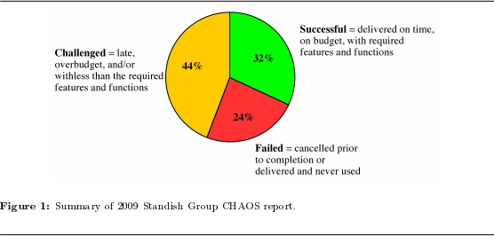

<https://cnx.org/contents/8KeV8AMJ@4/What-is-Project-Management>

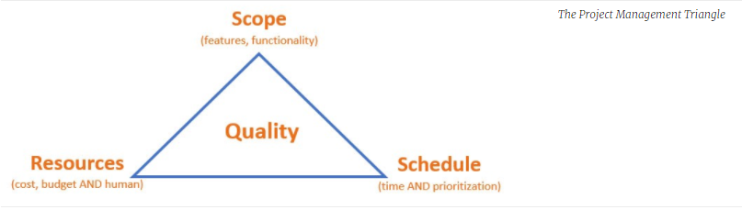

Source: <https://boagworld.com/digital-strategy/think-outside-of-the-project-management-triangle/>

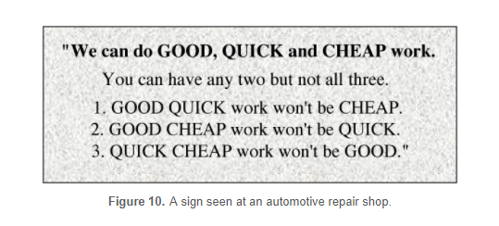

<https://cnx.org/contents/8KeV8AMJ@4/What-is-Project-Management>

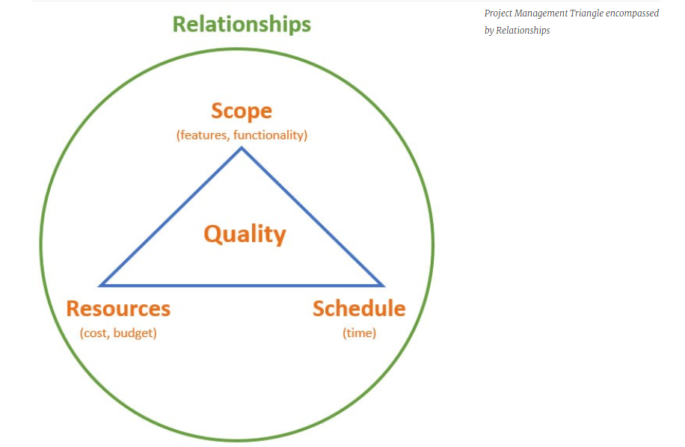

Source: <https://boagworld.com/digital-strategy/think-outside-of-the-project-management-triangle/>

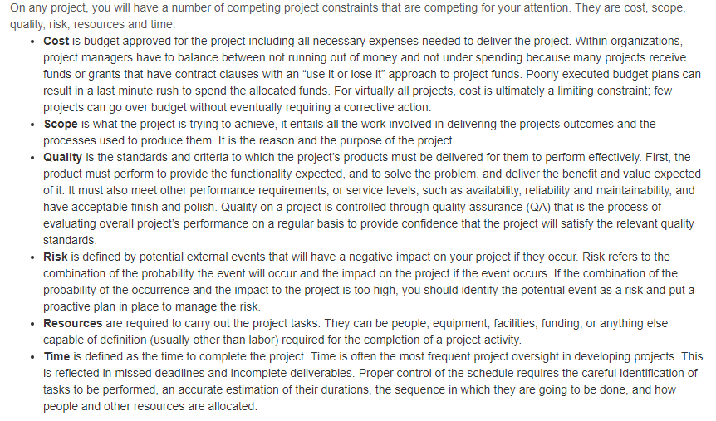

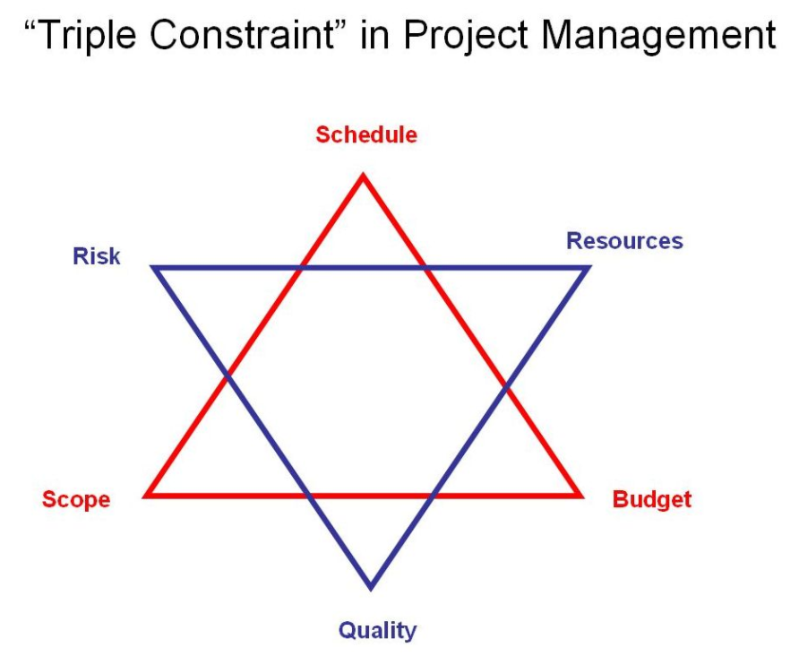

* In the Fourth Edition of [A Guide to the Project Management Body of Knowledge](http://www.brighthubpm.com/certification/124624-guide-to-studying-the-project-management-body-of-knowledge/)(Project Management Institute, 2009) yet another model was introduced. This one is based on the triple constraint but includes 6 elements to be managed.

The Star m[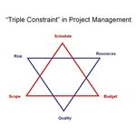](http://img.bhs4.com/85/7/857676601efdeea9d4d5676fd752c77b71e789cf_large.jpg)odel includes Scope, Cost, Time, Risk, Quality and Resources.

The purpose of this model was to make a distinction between project inputs on one triangle and project processes on the other triangle.

While incorporating more elements that reflect the real world of project management, the graphic becomes very challenging to use as a discussion tool

### The Future of the Project Management Triangle

… in the latest version of the Project Management Body of Knowledge (PMBOK), PMI minimizes the project management triangle because every project has many more constraints than cost, time and scope.

The concept of the project management triangle is still solid. It is a good way to have high level discussions about the impact of changes on a project. Variations of the classic project management triangle will continue to evolve. Since [change management](http://www.brighthubpm.com/change-management/125283-a-comprehensive-handbook-for-managing-change/) is a huge component of project management, the triangle, in whatever form it needs to be to get the message across, will continue to be a valuable resource in any project managers’ toolbox.

Source: <http://www.brighthubpm.com/methods-strategies/126255-shaping-our-message-with-the-project-management-triangle/#imgn_3>